GRADE 7 ACCELERATED · UNIT 1 · LESSON 4
Two-Step Equations in Context
Additional Practice 7A.01.04 ANSWER KEY

Lisa solved the equation −2x − 3 = 5. Her work is shown. Use it for question 1.
−2x − 3 + 3 = 5 + 3
−2x = 8
−2x ÷ (−2) = 8 ÷ (−2)
x = 4

1. Use substitution to decide whether Lisa's solution is correct. If it is not, describe her error and solve the equation correctly.
−2(4) − 3 = −8 − 3 = −11, and −11 ≠ 5, so it is not correct.
Her error: 8 ÷ (−2) is −4, not 4. She dropped the negative sign when she divided.
x = −4 Check: −2(−4) − 3 = 8 − 3 = 5 ✓

Zoey solved the equation 3m + 5 = 8. Her work is shown. Use it for question 2.
3m + 5 − 5 = 8 − 5
3m = −3
3m ÷ 3 = −3 ÷ 3
m = −1

2. Use substitution to decide whether Zoey's solution is correct. If it is not, describe her error and solve the equation correctly.
3(−1) + 5 = −3 + 5 = 2, and 2 ≠ 8, so it is not correct.
Her error: 8 − 5 is 3, not −3. The subtraction itself was done wrongly.
m = 1 Check: 3(1) + 5 = 3 + 5 = 8 ✓

For questions 3 through 5, solve the equation, then say what the solution means in the situation.
3. A taxi charges $1.75 plus $0.75 for each mile traveled. Your trip cost $14.50. The equation 1.75 + 0.75x = 14.50 represents the situation.
0.75x = 12.75 x = 17
The trip was 17 miles.
Check: 1.75 + 0.75(17) = 1.75 + 12.75 = 14.50.
4. A zipline course charges a flat rate of $75 plus $5.50 for each line you cross. One person's total was $124.50. The equation 75 + 5.50z = 124.50 represents the situation.
5.50z = 49.50 z = 9
That person crossed 9 lines.
5. A runner warms up for 15 minutes and then runs each mile in 6 minutes. The total time is 45 minutes. The equation 15 + 6m = 45 represents the situation.
6m = 30 m = 5
The runner ran 5 miles.

For questions 6 through 10, solve the equation and check your solution by substitution.
6. 125 = 15 + 5x
125 − 15 = 15 + 5x − 15
110 = 5x
110 ÷ 5 = 5x ÷ 5
22 = x
Check: 15 + 5(22) = 15 + 110 = 125 ✓
Subtraction property, then division property. The variable ends on the right; that is the symmetric property and it is finished.

 | 7. | 9.2 = 6.1 + | 

9.2 − 6.1 = 6.1 + h/6 − 6.1
3.1 = h/6
3.1 × 6 = (h/6) × 6
18.6 = h
Check: 6.1 + 18.6 ÷ 6 = 6.1 + 3.1 = 9.2 ✓
Subtraction property, then multiplication property.
8. 17.5c − 15 = 98.75
17.5c = 113.75
c = 6.5
Check: 17.5(6.5) − 15 = 113.75 − 15 = 98.75 ✓
Addition property, then division property.

 | 9. | 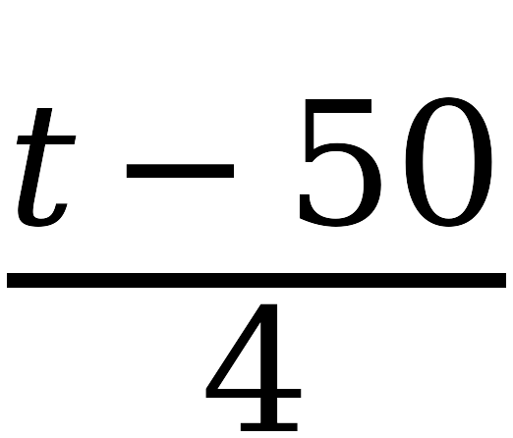 | = 400

(t − 50)/4 × 4 = 400 × 4
t − 50 = 1600
t = 1650
Check: (1650 − 50) ÷ 4 = 1600 ÷ 4 = 400 ✓
Multiplication property, then addition property. Here the whole numerator is divided by 4, so undo the division first.
10. 16.42 + 2.51r = 26.46
2.51r = 10.04
r = 4
Check: 16.42 + 2.51(4) = 16.42 + 10.04 = 26.46 ✓
Subtraction property, then division property.

